CIS 5th Annual Back to School BBQ

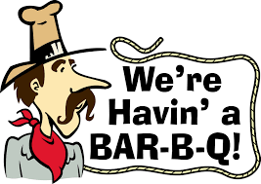
SAVE THE DATE!!
SATURDAY, SEPTEMBER 29th
Noon – 4pm

Who says there is no such thing as a free lunch? Come join the PTSO for a school-wide Back to School BBQ! We’ll have pulled pork from Queen City Q, along with Fried Chicken, hot dogs and all the fixin’s.

$5 wristbands will also be available to play games and unlimited bouncing in the bounce castles and the inflatable obstacle course.
Cotton Candy and Popcorn!
Plus, Balloon Animals from Mr. Vic!

